Your answer to the questions below

|  |
| --- |
| Insert into query  INSERT INTO Persons (PersonID, name, samplenumeric)  VALUES  (5, 'Max', 999),  (6, 'Oliver', 1111),  (7, 'Chloe', 2222),  (8, 'Milo', 3333),  (9, 'Simba', 4444),  (10, 'Cleo', 5555); |
| SELECT Query  SELECT name FROM Persons; |

Lab 1: Connecting to Loki

The goal of today’s lab is to get a start on working with Loki and the phpMyAdmin system.

You should have gotten an email from [noreply@loki.trentu.ca](mailto:noreply@loki.trentu.ca) with your username and password, if not, check your spam folder.

You have received an email regarding your Loki account at the portal: <https://loki.trentu.ca/portal/>.

If you have used Loki previously, your account already exists.  Your MYSQL password remains the same.  If you don’t remember your MYSQL password, you can change it in the portal: <https://loki.trentu.ca/portal/>.

That is the self-serve portal, you can set your pwd there and other stuff. There probably isn’t that much we need to do, but it’s there if you need it later.

Important for us is:

<https://loki.trentu.ca/phpmyadmin/index.php>

phpMyAdmin is an Administration console for a mySQL database hosted on Loki – as you might surmise from the name, the admin console was written in PHP.

1. Go to <https://loki.trentu.ca/phpmyadmin/index.php> and make sure you can login with the username and pwd provided in the email from [noreply@loki.trentu.ca](mailto:noreply@loki.trentu.ca)

When you login you should see something like:

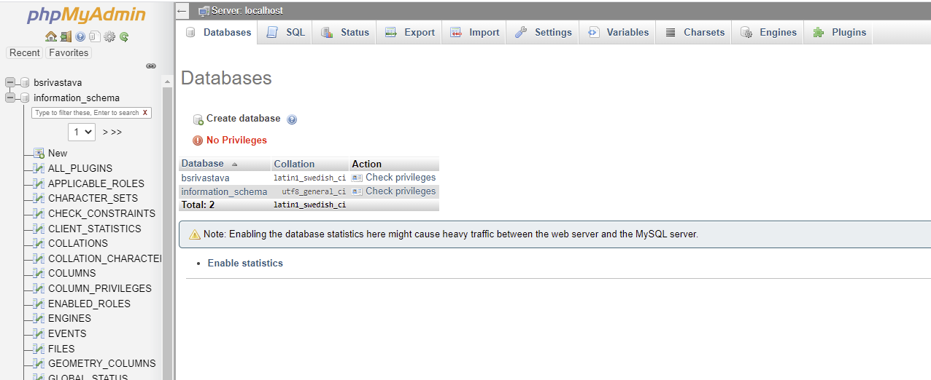

You can see there’s a bunch of cool stuff there, including being able to import and export entire DB schemas and so on.

1. You need to click on the database you want to run queries on, it’s on the Databases Tab and your database is your username:
2. A database is really just a thing that holds files, what you need in a database for anything to be useful is to create tables that hold the data. Note that much of this course is learning the right way to structure tables within a database, for today we are going to have a single table, just to make sure it works.   
     
   After you selected your database, select SQL on the top and run the following query:

CREATE TABLE Persons (

    PersonID int,

    name varchar(255),

    samplenumeric int

);

Run that Query by clicking “Go” in the bottom right corner:

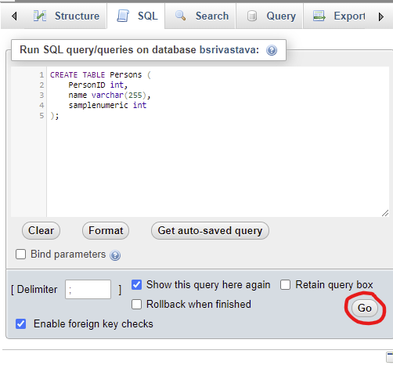

Ok Great, now you have an empty table.

1. Let’s put something in it

INSERT into Persons

VALUES (1, 'Bella', 555),

(2, 'Charlie', 666),

(3, 'Lucy', 777),

(4, 'Luna', 888);

1. Let’s look at a simple query – this allows us to find all of the elements meeting some criteria. Select statements get quite complicated (and interesting) as we go – but for now we’ll stick to a simple SELECT * (* means all) FROM (table) WHERE (conditions)

SELECT * FROM PERSONS WHERE samplenumeric > 600

Doesn’t work! AHHH panic… run away!

1. No really try this instead:

SELECT * FROM Persons WHERE samplenumeric > 600

So you learned that SQL is very temperamental about capitalisation.

1. Insert the following values into your persons table:

5. Max 999

6. Oliver 1111

7. Chloe 2222

8. Milo 3333

9. Simba 4444

10. Cleo 5555

Paste the SQL query you used for that in the box at the very beginning of this document.

**INSERT INTO Persons (PersonID, name, samplenumeric)**

**VALUES**

**(5, 'Max', 999),**

**(6, 'Oliver', 1111),**

**(7, 'Chloe', 2222),**

**(8, 'Milo', 3333),**

**(9, 'Simba', 4444),**

**(10, 'Cleo', 5555);**

1. Select name from Persons

Paste the SQL query and result above.

**SELECT name FROM Persons;**

This lab *should* be easy – except if your loki account isn’t setup right or the SQL database didn’t get created correctly, in which case, fixing that will be a top priority.